I’lam: Media Center for Arab Palestinians in Israel
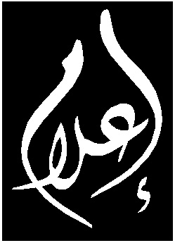
مركز إعلامي للمجتمع العربي الفلسطيني في إسرائيل
I’laM
Media Center for Arab Palestinians in Israel

I’lam Strongly Condemns Police Violence on Arab and Foreign Journalists during Right-Wing March in Umm al-Fahm

Press Release, March 24 2009

On March 24, during a right-wing march in Umm al-Fahm led by right-wing activists Itamar Ben-Gvi and Baruch Marzel, former head of the banned Kach party, a 2,500 strong contingent of the police used force and tear gas on Arabs protesting the march, including on Arab and foreign journalists that were present covering the event.

I’lam strongly condemns the police attack on journalists in Umm al-Fahm, towards whom police should take adequate care to protect so that they can effectively carry out their duties, cover the events and transfer facts to the public. I’lam Media Center affirms that such attacks on journalists at the hands of the Israeli security forces and police are on the increase, as evidenced most recently in I’lam’s documentation of attacks on Arab journalists covering the Gaza war. Such deliberate attacks on journalists indicates explicit efforts to suppress the right to freedom of expression, specifically that of the Palestinian community.
I’lam affirms that such attacks are a serious violation of international law, in particular the right to freedom of the press, to freedom of expression and information and to freedom of occupation, the latter being a constitutional right in Israel. Furthermore, such attacks on journalists also run contrary to the principle of the UN Security Council Resolution 1738 that strictly prohibits the use of violence on journalists who are to be considered as civilians in areas of armed conflict.

The ongoing attacks on journalists by the Israeli security forces and police highlight the lack of institutional awareness for a culture of human rights and for the significance of journalism in promoting democracy. Such a lack hints to the fragility of Israeli democracy. I’lam Media Center calls upon Israeli institutions to immediately halt their violations against journalists and to create an appropriate atmosphere for them to do their job of professionally covering the facts and transferring them to the public.

It should be noted that I’lam is working to collect testimony from those reporters attacked in Umm al-Fahm and will follow-up on documented complaints.

United Nations, ‘Security Council Condemns Attacks Against Journalists in Conflict Situations, Unanimously Adopting Resolution 1738 (2006)’, UN Doc. SC/8929/RES/1738 (December 2006).

