Tour for Journalists in:

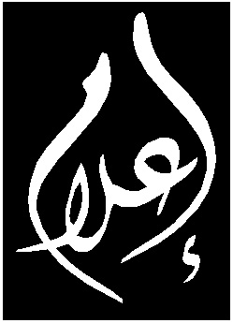

مركز إعلامي للمجتمع العربي في إسرائيل

מרכז תקשורת לחברה הערבית פלסטינית בישראל

Media Center for Arab Palestinians in
Israel

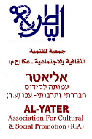

Akka

“Coexistence is just a slogan… Ultimately, Akko is a town like Raanana, Kfar Saba or Haifa, and must safeguard its Jewish identity. I think everyone would agree that Akko is the capital city of Galilee, of thousands of years of Jewish history. We are here to preserve that Jewish identity and to reinforce that spirit, to stand for our nation’s honor.” Quote from Rabbi Yossi Stern, head of the Hesder (combines Talmudic study with military service) Yeshiva ‘Ruach Tzfonit’, following assaults on Arab residents in ‘Akka in October 2008

Sunday, April 25 2010
10am – 5pm

Meet at 10am at the ‘Aroma’ Coffee-shop at the entrance to Akka. Chartered Bus transport has been organised from Tel Aviv. The bus will depart from Tel Aviv Central Train Station (also known as Arlozorov/Savidor Merkaz) at 8am.

Following findings and recommendations of I’lam’s last tour for journalists, we have organised for there to be an English translator present.

For more details and to register, please contact: Kholod Massalha, Hebrew Media Coordinator by phone: 0509319961, 046001370 or by email: kholod.massalha@ilam-center.org

Programme Schedule:
10-1030am: Reception and Welcome

1030-1130am: Barbour Neighbourhood. Meeting with residents from Barbour. 200 individuals live in this neighbourhood that lacks minimum municipal services.

12-1pm: Wolfson Neighbourhood. Developments following and Implications of the 2003 foundation of Yeshivat Ruach Tzfonit (“Winds from the North”) seminary in the neighbourhood

1-2pm: Trumpeldor Street: The Arab-Jewish dividing line in ‘Akka

2-3pm: Lunch

3-4pm: The Old City:
i) Visit to ‘No. 10’ Neighbourhood. The Israeli Antiquities Authorities renovated homes here in order to enable a population exchange of Jewish residents into the impoverished Arab ‘Old City’ as a project of gentrification.
ii) Khan ‘Al-‘Omdan’ (Inn of the Pillars): Implications of tourism development and Arab migration out of the city

4-5pm: Al Laz Theatre: Meetings with young Arab theatre performers – ‘Escape from Reality into Theatre’

