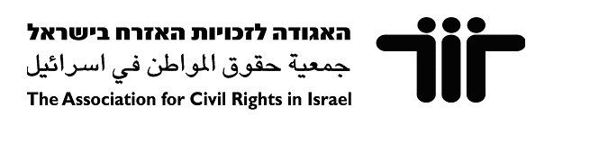

إعلام: مركز إعلامي للمجتمع العربي الفلسطيني في إسرائيل
מרכז תקשורת לחברה הערבית פלסטינית בישראל
I’lam: Media Center for Arab Palestinians in Israel



Tour for Journalists:
The Galilee

Friday, April 29 2011
10am-2pm

“The Bitter Reality of Housing Discrimination: Arabs towns in the Galilee caught between discriminatory planning and neighbouring Jewish towns’ Admission Committees”.
It may be denied in official government speak that there exists a policy of ‘Judaizing the Galilee’ in 2011, yet this policy manifests itself in the discriminatory objectives of the relevant Planning and Building Committees. Arab towns and villages exist in a state of neglect, while neighbouring Jewish communities enjoy well-developed infrastructure, and are peopled by those determined suitable by each town’s Admission Committee. An ‘Admission Committee’ Law, passed on March 22 2011, gave 700 such committees in the Naqab and Galilee full discretion in who is deemed suitable to live in that community. Such legal backing facilitates the exclusion of the ‘unsuitable’, among them Arab Palestinians.

As a means of unweaving these modes of discrimination and exclusion, I’lam Media Center and the Association for Civil Rights in Israel (ACRI) will be hosting a tour for journalists to two Arab villages and a neighbouring Jewish town in the Galilee on April 29 2011.

The tour will be a visit of three villages/towns:
- Ramiyyeh: Unrecognised village that existed prior to the foundation of the State. Number of residents are 150.
- Al-Husseiniyeh: Village recognised in 1995, with 800 inhabitants, but still lacking basic infrastructure.
- Ya’ad: Setup as an industrial cooperative (moshav) in 1974. In 1991, it was privatized and turned into a public town. 150 families live in the town. An Admission Committee decides on ‘suitable’ future residents.

Transport: The bus will depart at 730am from Tel Aviv Central Train Station (also known as Arlozorov/Savidor Merkaz) and will pass through Nazareth (around 9am).
Logistics: The tour runs from 10am to 2pm, with lunch provided.
Registration: To confirm registration or for further details, please contact:
- Coordinator of Tour, Samah Bsoul at 04-6001370 , email: samah.bsoul@ilam-center.org ; or
- International Relations Coordinator, Nasser Rego at email: nasser.rego@ilam-center.org

